**HW#4 RE Programming (COSE215, 2020 Spring)**

**Problem 1: Decode the Morse code**

Mr. Na, a secret agent, works for the government. His mission is to monitor and protect Korea University. One day, he was given an intel from another secret agent that some is trying to infiltrate one of Korea University’s Computer and Communication Security Lab. Mr. Na uses the old fashion Morse code to communicate with his agents.

**“.... - - .--. ... ---... -..-. -..-. .-- .-- .-- .-.-.- -. --- - .. --- -. .-.-.- ... --- -..-. . -..- . .-. -.-. .. ... . -....- ..--- -....- ..--- .---- .- -... ....- --... -.... -... -... ----- ..... ..-. ....- ---.. ..--- ....- ---.. . -.. ----- .- ....- -.. ..--- -.. --... .- .- -.... --... . .....”**

He only had limited amount of time to decipher the code, so, he decided to make use of regular expression to decipher to code.

Once the code is deciphered, Mr. Na will know what to do to save Computer and Communication Security Lab.

Your goal is to help Mr. Na by write a regular expression code that deciphers the Morse code correctly.

Morse Code Alphabet rule:

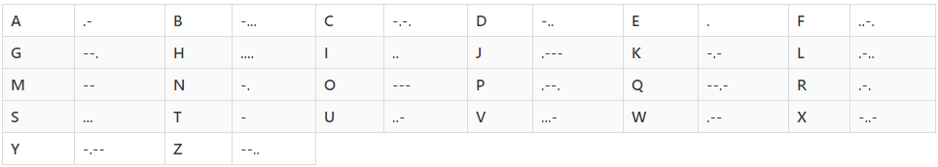



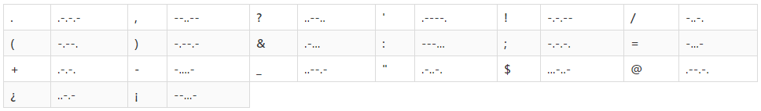

Your task is to write a RE program that ***covert the Morse code*** to a text message. You will be given a short Morse code that translates to English alphabet.

Your program’s input and output should be as follows:

Input: take all the string consist of “.” And “-“ as input

Output: return deciphered English string

**Remember to turn all Capital(upper-case) English alphabet to small(lower-case) alphabets  
The URL only take lower-case alphabets**

Once your program runs correctly, you will get the **URL** to the next problem!

Good luck…



BBL